COMPETENCY-BASED LEARNING MATERIALS (CBLM)

AI BASIC PYTHON DEVELOPER

TECHNICAL AND VOCATIONAL CERTIFICATE I — LEVEL II
Core Competency: Apply Structured Computer Programming
Module Title: Apply Structured Computer Programming
Learning Outcome: LO4 – String Handling in Python
Nominal Duration: Theory 3.5 Hours / Practical 9 Hours

L.O 04: STRING HANDLING IN PYTHON

Upon completion of this learning outcome, students or trainees will have the following competencies:
- Identify Python strings and their characteristics.
- Create strings using single and double quotation marks.
- Display strings using the print() function.
- Assign string values to variables.
- Create and assign multiline strings.
- Access individual string characters using indexing.
- Apply positive indexing to strings.
- Slice strings to extract required characters.
- Apply negative indexing to strings.
- Determine string length using len().
- Apply common Python string methods.
- Check whether characters or phrases exist within strings.
- Concatenate two or more strings.
- Format string output using the format() method.
- Apply escape characters in Python strings.
- Explain the immutable characteristic of Python strings.
- Create, save, execute and test Python programs involving strings.

INFORMATION SHEET No. 04

Title: Understanding Python String Handling

Objective
Upon reading this Information Sheet, the trainee must be able to:
- Define a Python string.
- Explain the characteristics of Python strings.
- Create strings using correct syntax.
- Display strings using print().
- Assign strings to variables.
- Create multiline strings.
- Access string characters by index.
- Apply positive and negative indexing.
- Extract string portions using slicing.
- Determine string length.
- Apply common built-in string methods.
- Search for characters and phrases.
- Concatenate strings.
- Format strings using format().
- Apply escape characters.
- Explain string immutability.

1. Introduction to Python Strings
A string is a sequence of characters used to represent text.
Strings are one of the most commonly used data types in Python.
Examples:
"Python"
"Hello World"
"AI Basic Python Developer"
A string may contain:
- Letters
- Numbers
- Spaces
- Symbols
- Punctuation
Example:
message = "Python 3 is easy!"
Check its type:
print(type(message))
Output:
<class 'str'>
The Python data type for strings is:
str

2. Creating Python Strings
Python strings can be created using either single quotation marks or double quotation marks.

Single Quotes
name = 'Dara'

Double Quotes
name = "Dara"
Both represent strings.
Example:
course1 = 'Python'
course2 = "Python"
print(course1)
print(course2)
Output:
Python
Python

3. Displaying Strings with print()
The print() function displays information on the screen.
Syntax:
print("text")
Example:
print("Hello Python")
Output:
Hello Python
Another example:
print("AI Basic Python Developer")
Output:
AI Basic Python Developer

4. Assigning a String to a Variable
A string can be stored in a variable.
Example:
name = "Dara"
Here:
- name is the variable.
- "Dara" is the string value.
Display the value:
print(name)
Output:
Dara
Another example:
course = "Python Programming"
institution = "Technical Training Center"
print(course)
print(institution)

5. Multiline Strings
A multiline string contains text across several lines.
Python supports multiline strings using triple quotation marks.

Triple Double Quotes
message = """Welcome to Python.
This course teaches Python programming.
Practice is important."""
print(message)

Triple Single Quotes
message = '''Welcome to Python.
Learn Python syntax.
Practice Python programming.'''
print(message)
Output preserves the line structure.

6. Strings as Sequences of Characters
A Python string is a sequence of characters.
Consider:
Python
The characters have positions called indexes.
Character | P | y | t | h | o | n
Positive Index | 0 | 1 | 2 | 3 | 4 | 5
Negative Index | -6 | -5 | -4 | -3 | -2 | -1
Python indexing begins at:
0
Therefore, the first character of "Python" is at index 0.

7. Accessing Characters Using Indexing
Individual characters can be accessed using square brackets.
Syntax:
string[index]
Example:
word = "Python"
print(word[0])
Output:
P
Example:
print(word[1])
Output:
y
Example:
print(word[5])
Output:
n

8. Character Position as an Array-Like Sequence
Although a Python string is not a list or array, its characters can be accessed using indexes in an array-like manner.
Example:
course = "Python"
print(course[0])
print(course[1])
print(course[2])
Output:
P
y
t
The important rule is:
The first character has index 0.

9. String Slicing
Slicing extracts part of a string.
Syntax:
string[start:end]
The start position is included.
The end position is excluded.
Example:
word = "Python"
print(word[0:3])
Output:
Pyt
Indexes:
P y t h o n
0 1 2 3 4 5
word[0:3] retrieves indexes:
0, 1, 2

10. Slicing from the Beginning
The starting index can be omitted.
Example:
word = "Python"
print(word[:3])
Output:
Pyt
This means:
Start from the beginning and stop before index 3.

11. Slicing to the End
The ending index can also be omitted.
Example:
word = "Python"
print(word[2:])
Output:
thon
This means:
Start at index 2 and continue to the end.

12. Slicing with Step
Python also supports a step value.
Syntax:
string[start:end:step]
Example:
word = "Python"
print(word[0:6:2])
Output:
Pto
This selects every second character.

13. Negative Indexing
Negative indexing counts characters from the end of the string.
The last character has index:
-1
Example:
word = "Python"
print(word[-1])
Output:
n
Example:
print(word[-2])
Output:
o
For "Python":
Character | P | y | t | h | o | n
Negative Index | -6 | -5 | -4 | -3 | -2 | -1

14. Negative Slicing
Negative indexes can also be used in slicing.
Example:
word = "Python"
print(word[-4:-1])
Output:
tho
This starts at index -4 and stops before index -1.

15. Determining String Length
The built-in len() function determines the number of characters in a string.
Syntax:
len(string)
Example:
word = "Python"
print(len(word))
Output:
6
Spaces are also counted.
Example:
message = "Hello Python"
print(len(message))
Output:
12
The space between Hello and Python counts as one character.

16. Python String Methods
Python provides many built-in methods for working with strings.
Common methods include:
Method | Purpose
upper() | Converts text to uppercase
lower() | Converts text to lowercase
capitalize() | Capitalizes first character
title() | Capitalizes words
strip() | Removes leading/trailing whitespace
replace() | Replaces text
split() | Splits a string
find() | Finds position of text
count() | Counts occurrences
startswith() | Checks beginning
endswith() | Checks ending

17. upper() Method
The upper() method converts letters to uppercase.
Example:
course = "python"
print(course.upper())
Output:
PYTHON

18. lower() Method
The lower() method converts letters to lowercase.
Example:
course = "PYTHON"
print(course.lower())
Output:
python

19. capitalize() Method
The capitalize() method converts the first character to uppercase.
Example:
text = "python programming"
print(text.capitalize())
Output:
Python programming

20. title() Method
The title() method capitalizes the first letter of each word.
Example:
text = "python programming language"
print(text.title())
Output:
Python Programming Language

21. strip() Method
The strip() method removes whitespace from the beginning and end.
Example:
name = " Dara "
print(name.strip())
Output:
Dara

22. replace() Method
The replace() method replaces specified text.
Example:
message = "I like Java"
print(message.replace("Java", "Python"))
Output:
I like Python

23. split() Method
The split() method separates a string into parts.
Example:
message = "Python is easy"
print(message.split())
Output:
['Python', 'is', 'easy']
A separator can also be specified.
Example:
data = "Dara,20,Python"
print(data.split(","))
Output:
['Dara', '20', 'Python']

24. find() Method
The find() method searches for text and returns its starting position.
Example:
message = "I like Python"
print(message.find("Python"))
Output:
7
If the text is not found, find() returns:
-1

25. Checking a Phrase or Character in a String
Python provides the membership operators:
in
not in
Example:
message = "Python is easy"
print("Python" in message)
Output:
True
Example:
print("Java" in message)
Output:
False

26. Checking a Character
A single character can also be checked.
Example:
word = "Python"
print("P" in word)
Output:
True
Example:
print("z" in word)
Output:
False

27. Using not in
The not in operator determines whether text does not exist in a string.
Example:
message = "Python Programming"
print("Java" not in message)
Output:
True

28. String Concatenation
Concatenation means joining strings together.
The + operator can concatenate strings.
Example:
first_name = "Dara"
last_name = "Sok"
full_name = first_name + last_name
print(full_name)
Output:
DaraSok
To include a space:
full_name = first_name + " " + last_name
print(full_name)
Output:
Dara Sok

29. Required Concatenation Exercise
Assign:
s = "favo"
t = "rite"
Concatenate s and t.
Example:
s = "favo"
t = "rite"
result = s + t
print(result)
Output:
favorite
This directly addresses Knowledge Requirement 1.13.

30. String Formatting
String formatting allows values to be inserted into strings.
Python provides the format() method.
Example:
name = "Dara"
age = 20
message = "My name is {} and I am {} years old.".format(name, age)
print(message)
Output:
My name is Dara and I am 20 years old.

31. format() with Numbered Placeholders
Placeholders can use indexes.
Example:
name = "Dara"
course = "Python"
message = "Student {0} studies {1}.".format(name, course)
print(message)
Output:
Student Dara studies Python.

32. format() with Named Placeholders
Named placeholders can also be used.
Example:
message = "Student {name} studies {course}.".format(
name="Dara",
course="Python"
)
print(message)
Output:
Student Dara studies Python.

33. Escape Characters
An escape character allows special characters to be included inside strings.
Escape sequences begin with:
\
Common escape sequences include:
Escape Sequence | Purpose
\n | New line
\t | Tab
\\ | Backslash
\' | Single quotation mark
\" | Double quotation mark

34. New Line —
Example:
print("Python\nProgramming")
Output:
Python
Programming

35. Tab — xample:
print("Name\tAge\tCourse")
print("Dara\t20\tPython")
Output resembles:
Name Age Course
Dara 20 Python

36. Quotation Marks in Strings
Example:
print("He said, \"Python is easy.\"")
Output:
He said, "Python is easy."

37. Backslash
To display a backslash, use:
\\
Example:
print("C:\\Python\\Projects")
Output:
C:\Python\Projects

38. Python Strings are Immutable
Python strings are immutable.
Immutable means that the individual characters of an existing string cannot be changed directly.
Example:
word = "Python"
The following is invalid:
word[0] = "J"
Python reports an error because strings cannot be modified by assigning a new value to an individual character.
Instead, create a new string.
Example:
word = "Python"
new_word = "J" + word[1:]
print(new_word)
Output:
Jython

39. Complete String Handling Example
course = "Python Programming"
print("Original:", course)
print("Length:", len(course))
print("First Character:", course[0])
print("Last Character:", course[-1])
print("Slice:", course[0:6])
print("Upper:", course.upper())
print("Lower:", course.lower())
print("Contains Python:", "Python" in course)
s = "favo"
t = "rite"
print("Concatenation:", s + t)
name = "Dara"
age = 20
print("My name is {} and I am {} years old.".format(name, age))
print("Python\nProgramming")
This program demonstrates the major string-handling concepts required in LO4.

SELF-CHECK No. 4.1

Part A: Multiple Choice
1. Which Python data type represents text?
A. int B. float C. str D. bool
2. Which function displays a string?
A. display() B. show() C. print() D. output()
3. Which is a valid string assignment?
A. name = Dara B. name = "Dara"
C. "name" = Dara D. name :=: Dara
4. Which can create a multiline string?
A. Triple quotation marks B. Parentheses only
C. Square brackets D. Curly brackets
5. What is the first index of a Python string?
A. -1 B. 0 C. 1 D. 2
6. Given word = "Python", what is word[0]?
A. P B. y C. n D. Python
7. What does word[0:3] return when word = "Python"?
A. Py B. Pyt C. Pyth D. Python
8. Which index retrieves the last character?
A. 0 B. 1 C. -1 D. -2
9. Which function determines string length?
A. size() B. length() C. count() D. len()
10. Which method converts a string to uppercase?
A. upper() B. uppercase() C. big() D. capital()
11. Which operator checks whether text exists in a string?
A. = B. in C. + D. is
12. Which operator concatenates strings?
A. - B. / C. + D. %
13. Which method is required in this LO for string formatting?
A. format() B. print() C. type() D. input()
14. Which escape sequence creates a new line?
A. \t B. \n C. \\ D. \"
15. Python strings are:
A. Mutable B. Immutable C. Numeric only D. Boolean only

ANSWER KEY No. 4.1

Part A
No. | Answer
1 | C
2 | C
3 | B
4 | A
5 | B
6 | A
7 | B
8 | C
9 | D
10 | A
11 | B
12 | C
13 | A
14 | B
15 | B

OPERATION SHEET No. 4.1

Title: Create, Access and Manipulate Python Strings

Performance Objective
Given a computer with Python installed and Python IDLE or another approved development environment, the trainee must create strings, access their characters, slice strings, use string methods, concatenate and format strings, apply escape characters, save the program and verify its output.

Description
This operation demonstrates the basic procedures required to create and manipulate Python string data.

Picture/Overview
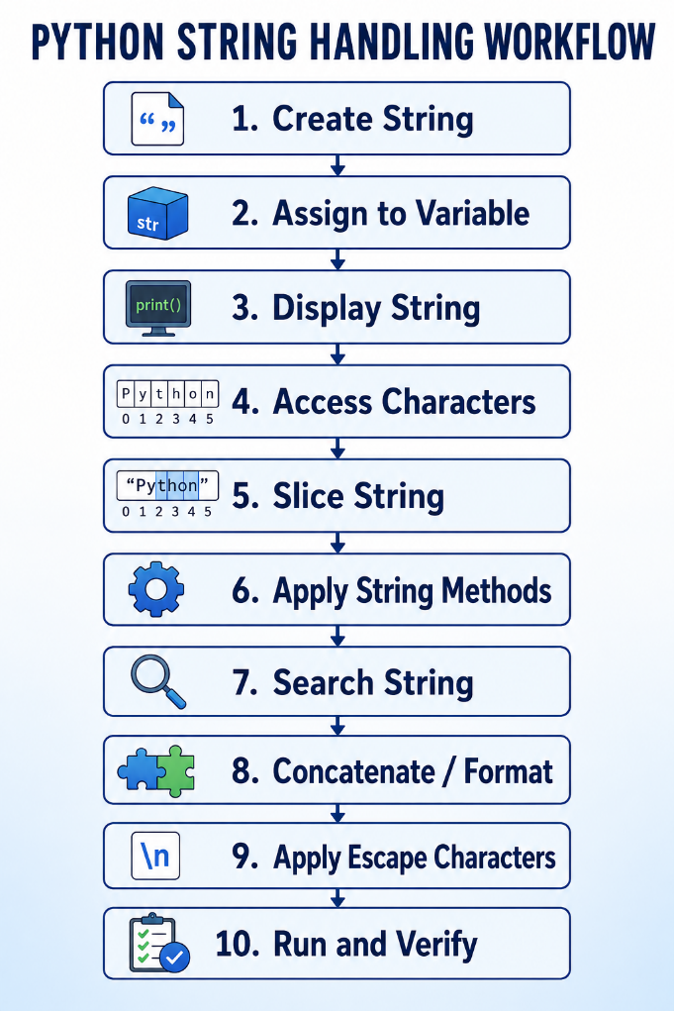
Figure 1: Python Strings

Tools, Equipment and Materials
No. | Description | Unit | Qty
1 | Desktop Computer/Laptop | Unit | 1
2 | Keyboard and Mouse | Set | 1
3 | Python 3.x | Copy | 1
4 | Python IDLE/IDE | Software | 1
5 | Command Prompt/Terminal | Software | 1
6 | Python Programming Reference Book | Copy | 1
7 | Programming Worksheet | Copy | 1

Supplier
Training institution / authorized software provider.

Procedure/Step | Key Performance
No. | Procedure/Step | Key Performance
1 | Open Python IDLE/IDE | Development environment opens successfully
2 | Create a Python source file | New program file is created
3 | Create a string | Correct quotation marks are used
4 | Assign string to variable | String value is correctly stored
5 | Display string | print() produces correct output
6 | Create multiline string | Triple quotes are correctly used
7 | Access characters | Correct indexes are used
8 | Slice string | Required substring is extracted
9 | Apply negative indexing | Correct character is retrieved
10 | Determine string length | len() returns correct length
11 | Apply string methods | Required transformations are correct
12 | Search string | Phrase/character is correctly checked
13 | Concatenate strings | Strings are joined correctly
14 | Apply format() | Values appear in correct placeholders
15 | Apply escape characters | Required formatted output is displayed
16 | Save program | .py extension is used
17 | Execute program | Program runs successfully
18 | Verify output | Actual output matches requirements

Operation Procedure

Step 1 — Create a String
course = "Python Programming"

Step 2 — Display the String
print(course)

Step 3 — Create a Multiline String
description = """Python is a programming language.
It is easy to learn.
It is widely used."""
print(description)

Step 4 — Access Characters
print(course[0])
print(course[1])
print(course[-1])

Step 5 — Slice the String
print(course[0:6])
print(course[:6])
print(course[7:])

Step 6 — Determine Length
print(len(course))

Step 7 — Apply Methods
print(course.upper())
print(course.lower())
print(course.replace("Python", "AI"))

Step 8 — Search
print("Python" in course)
print("Java" not in course)

Step 9 — Concatenate
s = "favo"
t = "rite"
print(s + t)

Step 10 — Format String
name = "Dara"
age = 20
print("My name is {} and I am {} years old.".format(name, age))

Step 11 — Apply Escape Characters
print("Name\tAge\tCourse")
print("Dara\t20\tPython")
print("Python\nProgramming")

Step 12 — Save
Save as:
string_handling.py

Step 13 — Execute and Verify
Run the program and compare actual results with the expected output.

Assessment Method
- Direct observation
- Practical demonstration
- Source-code inspection
- Program execution
- Output verification

TASK SHEET No. 4.2

Title: Create, Display and Access Python Strings

Performance Task
Create Python strings, assign them to variables, display them and access individual characters using positive and negative indexing.

Performance Objective
Given Python IDLE/IDE and programming requirements, the trainee must create single-line and multiline strings and retrieve required characters using correct indexes.

Description
The trainee will practice basic string creation, display, multiline strings and character indexing.

Picture/Overview
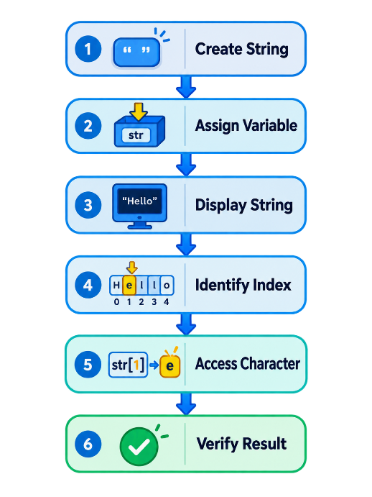
Figure 2: Task Sheet 1

Tools, Equipment and Materials
No. | Description | Unit | Qty
1 | Computer/Laptop | Unit | 1
2 | Python 3.x | Copy | 1
3 | Python IDLE/IDE | Software | 1
4 | String Exercise File | Set | 1
5 | Programming Worksheet | Copy | 1

Supplier
Training institution.

Procedure/Step | Key Performance
No. | Procedure/Step | Key Performance
1 | Open Python IDE | IDE opens successfully
2 | Create string variable | Correct syntax is used
3 | Display string | Correct output is produced
4 | Create multiline string | Triple quotes are used
5 | Access first character | Index 0 is correctly applied
6 | Access other characters | Correct positive indexes are used
7 | Access last character | Negative index -1 is applied
8 | Save and execute | Program runs correctly

Practical Exercise
Create:
course = "Python"
Display:
print(course)
Create:
message = """Welcome to Python.
Learn string handling.
Practice Python programming."""
Display the characters at:
Index 0
Index 1
Index 3
Index -1
Index -2
Complete:
Expression | Result
course[0] | __________
course[1] | __________
course[3] | __________
course[-1] | __________
course[-2] | __________

Assessment Method
- Direct observation
- Practical demonstration
- Worksheet review
- Output verification

TASK SHEET No. 4.3

Title: Apply String Slicing and Determine String Length

Performance Task
Extract required portions of strings using slicing and determine the number of characters in a string.

Performance Objective
Given a Python string and required character ranges, the trainee must correctly apply positive and negative slicing and use len() to determine string length.

Description
Use:
course = "Python Programming"
to practice string slicing.

Picture/Overview
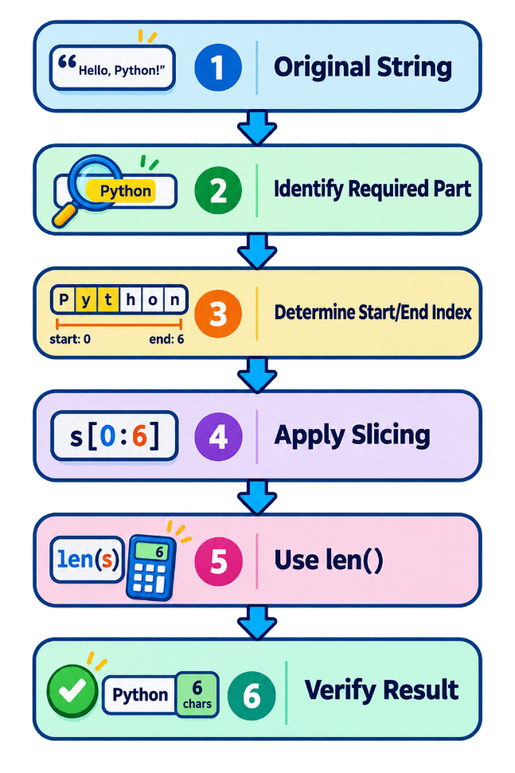
Figure 3: Apply String Slicing

Tools, Equipment and Materials
No. | Description | Unit | Qty
1 | Computer/Laptop | Unit | 1
2 | Python 3.x | Copy | 1
3 | Python IDE | Software | 1
4 | Worksheet | Copy | 1

Supplier
Training institution.

Procedure/Step | Key Performance
No. | Procedure/Step | Key Performance
1 | Create string | Correct value is assigned
2 | Identify indexes | Required positions are determined
3 | Apply positive slicing | Correct substring is extracted
4 | Slice from beginning | Omitted start index is correctly used
5 | Slice to end | Omitted end index is correctly used
6 | Apply negative slicing | Required substring is extracted
7 | Use len() | Correct length is returned
8 | Verify output | Results match requirements

Practical Exercise
course = "Python Programming"
print(course[0:6])
print(course[:6])
print(course[7:])
print(course[-11:])
print(len(course))
Complete:
Expression | Result
course[0:6] | __________
course[:6] | __________
course[7:] | __________
course[-11:] | __________
len(course) | __________

Assessment Method
- Direct observation
- Practical exercise
- Worksheet review
- Output verification

TASK SHEET No. 4.4

Title: Apply Python String Methods and Search Strings

Performance Task
Use built-in string methods to manipulate string values and search for characters and phrases.

Performance Objective
Given a Python string, the trainee must apply common string methods and determine whether specified characters or phrases exist within the string.

Description
The trainee will practice:

upper()
lower()
capitalize()
title()
strip()
replace()
split()
find()
in
not in

Picture/Overview
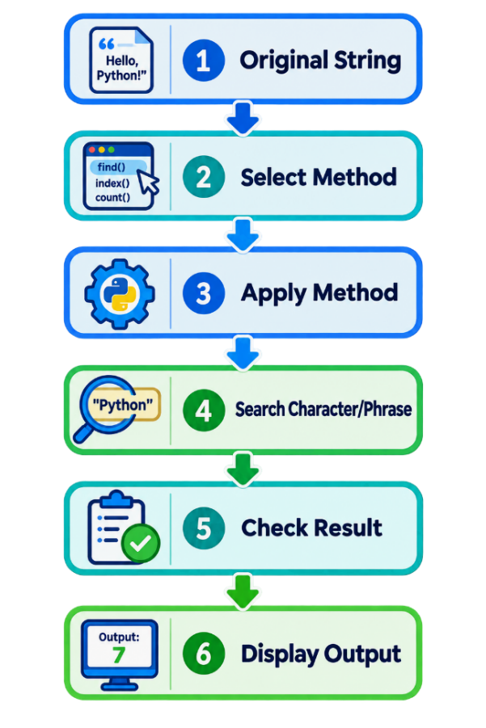
Figure 4: Apply Python String Methods

Tools, Equipment and Materials
No. | Description | Unit | Qty
1 | Computer/Laptop | Unit | 1
2 | Python 3.x | Copy | 1
3 | Python IDE | Software | 1
4 | Programming Worksheet | Copy | 1
5 | Python Reference Book | Copy | 1

Supplier
Training institution.

Procedure/Step | Key Performance
No. | Procedure/Step | Key Performance
1 | Create string | String is assigned correctly
2 | Apply upper() | Uppercase result is correct
3 | Apply lower() | Lowercase result is correct
4 | Apply title() | Title-case result is correct
5 | Apply strip() | Leading/trailing spaces are removed
6 | Apply replace() | Specified text is replaced
7 | Apply split() | String is separated correctly
8 | Apply find() | Correct position is returned
9 | Apply in | Presence is correctly determined
10 | Apply not in | Absence is correctly determined
11 | Verify output | Results are correct

Practical Exercise
message = " Python Programming is Easy "
print(message.upper())
print(message.lower())
print(message.title())
print(message.strip())
print(message.replace("Easy", "Powerful"))
print(message.split())
print(message.find("Python"))
print("Python" in message)
print("Java" not in message)
Record your results.
Operation | Result
upper() | __________________________
lower() | __________________________
title() | __________________________
strip() | __________________________
replace() | __________________________
split() | __________________________
find("Python") | __________________________
"Python" in message | __________________________
"Java" not in message | __________________________

Assessment Method
- Direct observation
- Practical demonstration
- Source-code inspection
- Output verification

TASK SHEET No. 4.5

Title: Concatenate and Format Python Strings

Performance Task
Combine strings using concatenation and create formatted output using the format() method.

Performance Objective
Given several string variables and values, the trainee must concatenate strings and correctly insert values into formatted strings using format().

Description
The trainee will practice the + operator and format() method.

Picture/Overview
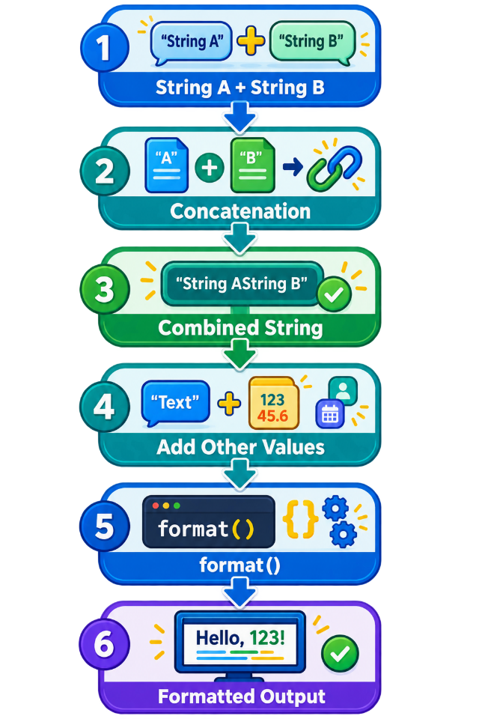
Figure 5: Concatenate and Format Python Strings

Tools, Equipment and Materials
No. | Description | Unit | Qty
1 | Computer/Laptop | Unit | 1
2 | Python 3.x | Copy | 1
3 | Python IDE | Software | 1
4 | Worksheet | Copy | 1

Supplier
Training institution.

Procedure/Step | Key Performance
No. | Procedure/Step | Key Performance
1 | Create string variables | Values are assigned correctly
2 | Apply + | Strings are concatenated correctly
3 | dd spaces where required | Output is readable
4 | Create format string | Placeholders are correct
5 | Apply format() | Values appear in correct positions
6 | Display output | Correct string is displayed
7 | Save and execute | Program runs successfully

Practical Exercise A
Assign:
s = "favo"
t = "rite"
Concatenate and display the result.
Expected:
favorite

Practical Exercise B
Create:
first_name = "Dara"
last_name = "Sok"
Produce:
Dara Sok

Practical Exercise C
Given:
name = "Dara"
age = 20
course = "Python"
Use format() to produce:
My name is Dara. I am 20 years old and I study Python.

Assessment Method
- Practical demonstration
- Direct observation
- Source-code inspection
- Output verification

TASK SHEET No. 4.6

Title: Implement Escape Characters in Python Strings

Performance Task
Apply Python escape characters to produce formatted text output.

Performance Objective
Given text-output requirements, the trainee must correctly apply newline, tab, quotation-mark and backslash escape sequences.

Description
The trainee will use:
\n
\t
\"
\'
\\

Picture/Overview
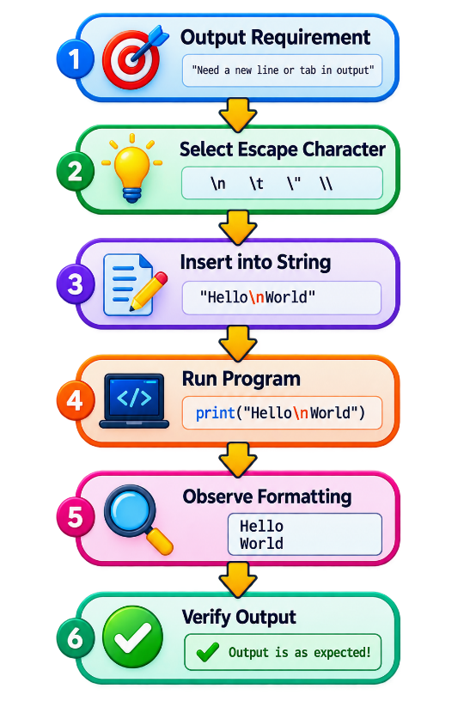
Figure 6: Implement Escape Characters in Python Strings

Tools, Equipment and Materials
No. | Description | Unit | Qty
1 | Computer/Laptop | Unit | 1
2 | Python 3.x | Copy | 1
3 | Python IDE | Software | 1
4 | Worksheet | Copy | 1

Supplier
Training institution.

Procedure/Step | Key Performance
No. | Procedure/Step | Key Performance
1 | 1. Identify output requirement | Appropriate escape sequence is selected
2 | 2. Apply \n | New line is correctly displayed
3 | 3. Apply \t | Tab spacing is displayed
4 | 4. Apply \" or \' | Quotation mark is displayed correctly
5 | 5. Apply \\ | Backslash is displayed correctly
6 | 6. Execute program | Program runs successfully
7 | 7. Verify output | Formatting meets requirements

Practical Exercise
Create output using:
print("Python\nProgramming")
print("Name\tAge\tCourse")
print("Dara\t20\tPython")
print("He said, \"Python is easy.\"")
print("C:\\Python\\Projects")

Assessment Method
- Direct observation
- Practical demonstration
- Program execution
- Output verification

JOB SHEET No. 4.1

Title: Develop a Student String Information Processing Program

Performance Task
Develop a complete Python program demonstrating the required string-handling operations.

Performance Objective
Given a computer, Python IDLE/IDE and program requirements, the trainee must create, save, execute, test and verify a Python program that demonstrates string declaration, indexing, slicing, string methods, searching, concatenation, formatting and escape characters.

Description
Develop a program named:
student_string_profile.py
The program will create and process student and course information using Python strings.
The program must demonstrate all major LO4 string-handling competencies.

Picture/Overview
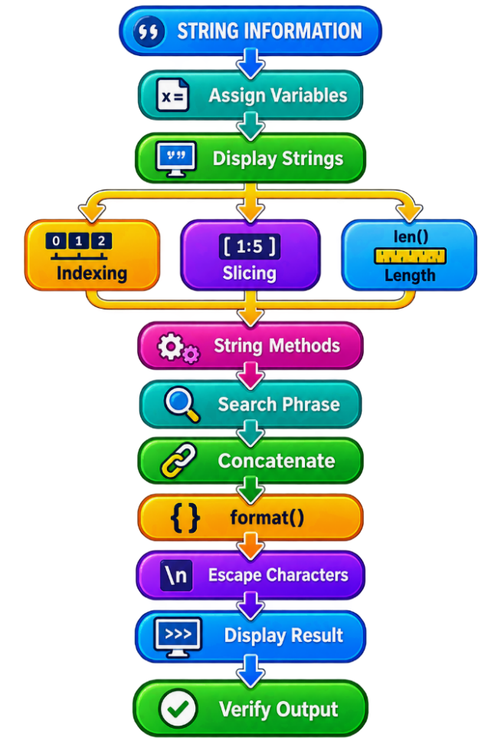
Figure 7: String Information Processing Program

Tools, Equipment and Materials
No. | Description | Unit | Qty
1 | Desktop Computer/Laptop | Unit | 1
2 | Keyboard and Mouse | Set | 1
3 | Python Programming Software 3.x | Copy | 1
4 | Python IDLE/IDE | Software | 1
5 | Command Prompt/Terminal | Software | 1
6 | Python Programming Reference Book | Copy | 1
7 | Python String Exercise Files | Set | 1
8 | Programming Worksheet | Copy | 1

Supplier
Training institution / authorized software provider.

Procedure/Step | Key Performance
No. | Procedure/Step | Key Performance
1 | Analyze program requirements | Required string operations are identified
2 | Open Python IDE | Development environment opens successfully
3 | Create source file | New Python program is created
4 | Create string variables | Correct string syntax is used
5 | Display strings | print() works correctly
6 | Create multiline string | Triple quotation marks are correctly applied
7 | Access characters | Correct indexes are used
8 | Apply positive indexing | Required characters are retrieved
9 | Apply negative indexing | Characters from end are retrieved
10 | Apply slicing | Required substrings are extracted
11 | Determine string length | len() returns correct result
12 | Apply string methods | Required string manipulation is performed
13 | Search for phrase | in/not in produces correct Boolean result
14 | Search character | Required character is correctly checked
15 | Concatenate strings | Strings are combined correctly
16 | Concatenate s and t | favorite is produced
17 | Apply format() | Formatted information is displayed correctly
18 | Apply escape characters | Formatted text output is correct
19 | Save program | .py extension is used
20 | Execute program | Program runs successfully
21 | Check program output | Actual output is reviewed
22 | Correct identified errors | Program is corrected as required
23 | Re-execute program | Corrected program runs
24 | Verify final output | Output matches requirements

Program Requirements

Part 1 — Create String Variables
Create:
student_name = "Dara Sok"
course = "Python Programming"
institution = "Technical Training Center"

Part 2 — Create a Multiline String
Create a multiline course description.
Example:
description = """Python Programming Course
Learning Outcome: String Handling
Level: II"""

Part 3 — Display Information
Display all string variables using print().

Part 4 — Access Characters
Display:
- First character of student name.
- Second character of student name.
- Last character of student name.
- First character of course.
- Last character of course.

Part 5 — Slice Strings
Extract:
Python
Programming
from:
Python Programming
using slicing.

Part 6 — Determine Length
Display:
len(student_name)
len(course)

Part 7 — Apply String Methods
Display the course using:
upper()
lower()
title()
Use replace() to replace:
Python
with:
AI Python

Part 8 — Search String
Check whether:
Python
exists in the course.
Check whether:
Java
exists in the course.

Part 9 — Required Concatenation
Create:
s = "favo"
t = "rite"
Concatenate:
favorite = s + t
Display:
favorite

Part 10 — Format Information
Use format() to display:
Student Dara Sok is studying Python Programming.

Part 11 — Escape Characters
Display a student information header using \t.
Example:
print("Name\tCourse")
print("Dara Sok\tPython Programming")
Display multiple lines using \n.

Example Program
# Student String Information Processing Program
student_name = "Dara Sok"
course = "Python Programming"
institution = "Technical Training Center"
description = """Python Programming Course
Learning Outcome: String Handling
Level: II"""
print("STUDENT INFORMATION")
print("Name:", student_name)
print("Course:", course)
print("Institution:", institution)
print("\nCOURSE DESCRIPTION")
print(description)
print("\nSTRING INDEXING")
print("First character:", student_name[0])
print("Second character:", student_name[1])
print("Last character:", student_name[-1])
print("\nSTRING SLICING")
print(course[0:6])
print(course[7:])
print("\nSTRING LENGTH")
print("Student name length:", len(student_name))
print("Course length:", len(course))
print("\nSTRING METHODS")
print("Upper:", course.upper())
print("Lower:", course.lower())
print("Title:", course.title())
print("Replace:", course.replace("Python", "AI Python"))
print("\nSTRING SEARCH")
print("Python" in course)
print("Java" in course)
print("\nSTRING CONCATENATION")
s = "favo"
t = "rite"
print(s + t)
print("\nSTRING FORMAT")
print("Student {} is studying {}.".format(student_name, course))
print("\nESCAPE CHARACTERS")
print("Name\tCourse")
print("{}\t{}".format(student_name, course))
print("Python\nProgramming")

Example Expected Output
STUDENT INFORMATION
Name: Dara Sok
Course: Python Programming
Institution: Technical Training Center
COURSE DESCRIPTION
Python Programming Course
Learning Outcome: String Handling
Level: II
STRING INDEXING
First character: D
Second character: a
Last character: k
STRING SLICING
Python
Programming
STRING LENGTH
Student name length: 8
Course length: 18
STRING METHODS
Upper: PYTHON PROGRAMMING
Lower: python programming
Title: Python Programming
Replace: AI Python Programming
STRING SEARCH
True
False
STRING CONCATENATION
favorite
STRING FORMAT
Student Dara Sok is studying Python Programming.
ESCAPE CHARACTERS
Name Course
Dara Sok Python Programming
Python
Programming

WORKSHEET No. 4.1

Title: Python String Handling Practice Worksheet
Trainee Name:
Date:

Part A — Identify Strings
Identify whether each value is a Python string.
Value | String? Yes/No
"Python" | ______
20 | ______
'Dara' | ______
85.5 | ______
"20" | ______
True | ______

Part B — Indexing
Given:
word = "Python"
Complete:
Expression | Result
word[0] | ______
word[1] | ______
word[2] | ______
word[5] | ______
word[-1] | ______
word[-2] | ______

Part C — Slicing
Given:
course = "Python Programming"
Complete:
Expression | Result
course[0:6] | __________________
course[:6] | __________________
course[7:] | __________________
course[-11:] | __________________

Part D — String Length
Determine:
len("Python")
Answer: __________________
len("Hello")
Answer: __________________
len("Hello World")
Answer: __________________

Part E — String Methods
Given:
text = "Python Programming"
Complete:
Method | Result
text.upper() | __________________
text.lower() | __________________
text.title() | __________________
text.replace("Python", "AI") | __________________
text.find("Python") | __________________

Part F — Search
Given:
course = "Python Programming"
Determine:

Expression | Result
"Python" in course | ______
"Java" in course | ______
"P" in course | ______
"Java" not in course | ______

Part G — Concatenation
Given:
s = "favo"
t = "rite"
Write the Python statement required to produce:
favorite
Answer:

Part H — format()
Given:
name = "Dara"
course = "Python"
Use format() to produce:
Dara studies Python.
Answer

Part I — Escape Characters
Write the appropriate escape sequence.
Requirement | Escape Sequence
New line | ______
Tab | ______
Backslash | ______
Double quotation mark | ______

PERFORMANCE CHECKLIST No. 4.1

Title: String Handling in Python
Name:
Date:

Did you use all these performance criteria during your task?
No. | Criteria | Yes | No
1 | Identified Python strings correctly | ☐ | ☐
2 | Explained basic string characteristics | ☐ | ☐
3 | Applied correct string syntax | ☐ | ☐
4 | Created strings using single or double quotation marks | ☐ | ☐
5 | Displayed strings using print() | ☐ | ☐
6 | Assigned string values to variables | ☐ | ☐
7 | Created a multiline string | ☐ | ☐
8 | Used triple quotation marks correctly | ☐ | ☐
9 | Identified string character positions | ☐ | ☐
10 | Accessed individual characters using indexing | ☐ | ☐
11 | Applied positive indexing correctly | ☐ | ☐
12 | Applied negative indexing correctly | ☐ | ☐
13 | Applied string slicing correctly | ☐ | ☐
14 | Applied negative slicing correctly | ☐ | ☐
15 | Determined string length using len() | ☐ | ☐
16 | Applied upper() correctly | ☐ | ☐
17 | Applied lower() correctly | ☐ | ☐
18 | Applied other required string methods | ☐ | ☐
19 | Searched for a phrase within a string | ☐ | ☐
20 | Searched for a character within a string | ☐ | ☐
21 | Applied in correctly | ☐ | ☐
22 | Applied not in correctly | ☐ | ☐
23 | Concatenated strings using + | ☐ | ☐
24 | Assigned s = "favo" correctly | ☐ | ☐
25 | Assigned t = "rite" correctly | ☐ | ☐
26 | Concatenated s and t to produce favorite | ☐ | ☐
27 | Applied the format() method correctly | ☐ | ☐
28 | Used placeholders correctly | ☐ | ☐
29 | Applied newline escape character \n | ☐ | ☐
30 | Applied tab escape character \t | ☐ | ☐
31 | Applied quotation-mark escape characters | ☐ | ☐
32 | Applied backslash escape character | ☐ | ☐
33 | Recognized that Python strings are immutable | ☐ | ☐
34 | Created and saved the Python program with .py extension | ☐ | ☐
35 | Executed the Python program successfully | ☐ | ☐
36 | Checked program output | ☐ | ☐
37 | Corrected basic string-handling errors | ☐ | ☐
38 | Verified the final output against requirements | ☐ | ☐

Comment:

Overall Assessment
Competent: ☐ Yes ☐ No
Needs Further Practice: ☐ Yes ☐ No

Name and Signature of Trainer
Name:
Signature:
Date:

